Ports and Port Accesses

Suppose the diagram has a complex node as the one on the picture.
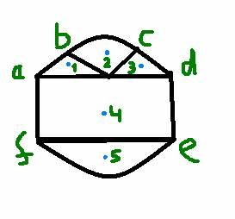

GLEE does not need to know how exactly the node is constructed from inside, but it needs to know something.
The boundary curve is needed for finding the tips of the arrow heads of edges going to the node and for avoiding the node for all other edges.
This node has five ports p1, p2, p3, p4 and p5 which are marked by blue dots. GLEE needs to know how to access ports. For this we may introduce a notion of port access. A port access is a set of the boundary curve segments, where each segment is given by its start and end parameters. In the example the ports with their accesses could be specified as the following.

p1 [a,b] ,
p2 [b,c]
p3 [c,d]
p4 [f,a], [d,e]
p5 [e,f]

It gives for GLEE just enough information to route the splines without too much guessing. For example it says that port 4 can be accessed both from the left and from the right.

